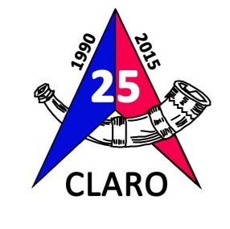
CLARO Orienteering Club
The Orienteering Club for Harrogate, Ripon and Surrounding Areas

With Compliments

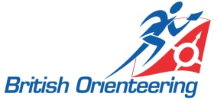
<ROLE> | CLARO Orienteering Club | c/o <address>
<name>@claro-orienteering.org.uk | www.claro-orienteering.org.uk
CLARO is an affiliated club of British Orienteering

CLARO Orienteering Club
The Orienteering Club for Harrogate, Ripon and Surrounding Areas

With Compliments

<ROLE> | CLARO Orienteering Club | c/o <address>
<name>@claro-orienteering.org.uk | www.claro-orienteering.org.uk
CLARO is an affiliated club of British Orienteering

CLARO Orienteering Club
The Orienteering Club for Harrogate, Ripon and Surrounding Areas

With Compliments

<ROLE> | CLARO Orienteering Club | c/o <address>
<name>@claro-orienteering.org.uk | www.claro-orienteering.org.uk
CLARO is an affiliated club of British Orienteering

